4.4 Algorithm Evaluation Results
Final defense-ready evidence pack for PCOSina
Generated and locally revalidated: 2026-05-17 14:45:08 PHT | Checkout: 2f0bd7e
Bottom line. The section is now defense-ready if it is presented as software and algorithm validation, not clinical validation. The main result is the deterministic hard-filter plus OR-Tools CP-SAT planner. LightGBM is included only as an optional Stage 1 ranking assist. A compact algorithm comparison is useful, but it should stay short so it does not distract from the final chosen approach.

4.4.1 Algorithm Evaluation Setup and Retest Status
PCOSina was evaluated as an offline-first wellness decision-support planner. The tested algorithmic contract is deterministic candidate filtering, optional assistive candidate ranking, and deterministic 0-1 weekly assignment optimization implemented through OR-Tools CP-SAT. ML is not the final authority and cannot override allergies, exclusions, hard budget caps, pantry feasibility rules, nutrition bounds, repetition/variety rules, or explicit hard preferences.
Table 4.4.1 Evaluation Setup and Traceability
Setup Item | Final Evidence Used
Local validation date | 2026-05-17 14:45:08 PHT
Checkout recorded | 2f0bd7e; local working tree had uncommitted thesis/application changes, so the final submitted branch should be tagged after commit.
Environment | Windows 11 Home Single Language 10.0.26200, 64-bit; Intel Core i5-11400H, 6 cores / 12 logical processors; about 7.7 GB RAM; Python 3.12.10
Final planner under evaluation | Deterministic hard filtering + Stage 1 shortlist/ranking + OR-Tools CP-SAT weekly assignment.
Scenario benchmark policy | Five thesis-facing scenarios S1-S5; successful scenarios expected to fill 21 meal slots; S5 intentionally infeasible.
Stage 1 candidate pool cap | 120 candidates in the final scenario benchmark table when the filtered pool exceeded the cap.
LightGBM artifact | ml/offline_training/artifacts/model_v1/training_metrics.json; model_v1 trained with request-level leakage control.
Success definition | Complete 7-day, 3-meal plan with 21 / 21 slots and no observed hard-constraint violation.
Failure success definition | For infeasible hard constraints, return a structured no-safe-plan response instead of forcing an unsafe plan.

Table 4.4.2 Local Retest Receipt
Retest Area | Command | Observed Result
Backend planner/contract tests | python -m pytest backend/tests/test_policy_config.py backend/tests/test_schema_contract.py backend/tests/test_planner_response_contract.py backend/tests/test_no_safe_plan_contract.py backend/tests/test_worker_plan_jobs.py backend/tests/test_meal_planner.py -q | 74 passed in 8.46 s
ML/ranking tests | python -m pytest backend/tests/test_ml_ranker.py backend/tests/test_lightgbm_training.py backend/tests/test_ml_dataset_builder.py backend/tests/test_ml_readiness_script.py -q | 12 passed in 7.66 s
Benchmark artifact manifest | python benchmarks/runner/run_comment5_benchmark.py --use-existing-artifacts | Manifest regenerated and 6 existing Comment #5 artifacts copied into benchmarks/reports.
Android connected tests | .\gradlew connectedDebugAndroidTest | Not executed in this local retest batch; do not use this document to claim device-lab/instrumented-test completion.

4.4.2 Benchmark Scenario Descriptions
Table 4.4.3 Benchmark Scenario Descriptions
Scenario | Description | Main Constraint Tested
S1 Base | Standard profile without added restrictions. | General 21-slot generation, nutrition deviation, and runtime
S2 Budget and No Pork | Profile with PHP 1,000 weekly budget and No Pork restriction. | Hard budget cap and restriction filtering
S3 Vegetarian and Lactose Intolerant | Profile with combined dietary restrictions. | Restrictive candidate pool handling
S4 Pantry-Aware Case | Profile with pantry ingredients and No Beef restriction. | Pantry-overlap ranking and grocery practicality
S5 Resilience/Stress Case | Profile with an intentionally infeasible PHP 20 weekly budget. | No-safe-plan handling, hard budget boundary, and safe failure behavior

4.4.3 Stage 1 Candidate Filtering and Shortlisting
Stage 1 reduces the planning search space before CP-SAT assignment. This does not decide the final meal plan; it only shapes the candidate set that the final solver may consider. The strongest defense wording is that Stage 1 improves tractability and ranking quality while Stage 2 remains authoritative.
Table 4.4.4 Final-Build Runtime and Safe Completion Results
Scenario | Candidate Pool Pre/Post | Planner Result | Safe Completion Outcome
S1 Base | 202 / 120 | Success | 21 / 21 slots, 0 hard violations
S2 Budget and No Pork | 177 / 120 | Success | 21 / 21 slots, hard budget cap met
S3 Vegetarian and Lactose Intolerant | 102 / 102 | Success | 21 / 21 slots, 0 hard violations
S4 Pantry-Aware Case | 222 / 120 | Success | 21 / 21 slots, 38 pantry-overlap matches
S5 Resilience/Stress Case | 177 / 120 | No-safe-plan | No unsafe plan returned; infeasible hard budget preserved

Figure 4.4 Runtime by scenario.
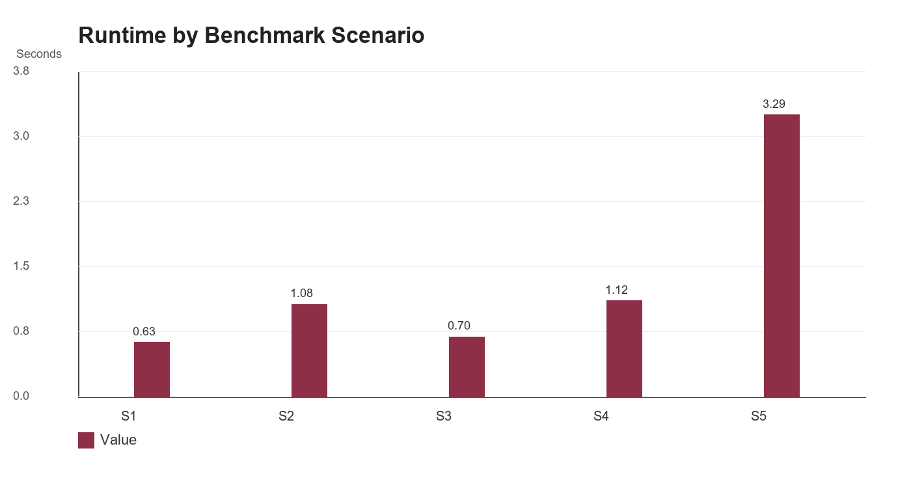
Figure 4.5 Candidate pool before and after Stage 1 cap.
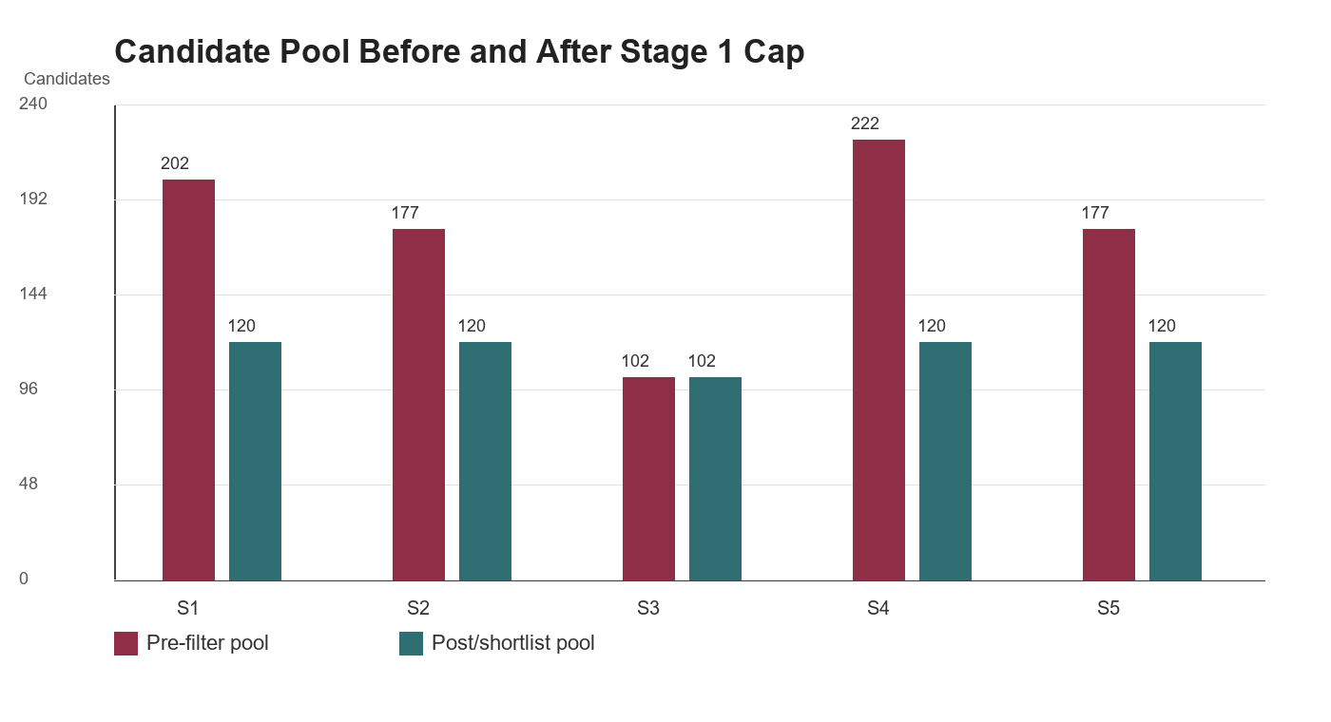

4.4.4 Stage 1 LightGBM Ranking Evaluation
The current repository artifact supports a compact LightGBM subsection. It should not replace the optimizer result. The label is solver-derived: selected candidates are positive examples and non-selected candidates are negative examples. Leakage control uses request_id as the split unit, which is more defensible than randomly mixing candidate rows from the same request across train and test.
Table 4.4.5 LightGBM Dataset and Split Summary
Metric | Current Artifact Value
Model name | lightgbm_stage1_ranker_v1
Dataset rows | 74,112 rows
Requests / users | 360 requests / 60 users
Positive label | 4,644 solver-selected rows; positive rate 6.27%
Train / validation / test rows | 60,319 / 7,350 / 6,443
Leakage control | hash(request_id) modulo 10 split using request_id
Feature groups | Nutrition distance, cost/budget, pantry overlap, cooking time, restrictions, meal-slot flags, profile attributes, and feedback-reason counts.

Table 4.4.6 LightGBM Ranking Metrics
Metric | Validation | Test | Interpretation
AUC | 0.9545 | 0.9373 | Separates solver-selected from non-selected candidates.
NDCG@10 | 0.9308 | 0.9211 | Selected candidates tend to appear high in ranked lists.
MAP@10 | 0.6953 | 0.6779 | Measures top-k precision for solver-selected candidates.
Heuristic baseline NDCG@10 | 0.8943 | 0.8838 | Non-ML deterministic baseline.
Heuristic baseline MAP@10 | 0.6456 | 0.6275 | Non-ML deterministic baseline.
Uplift vs baseline | NDCG@10 +0.0365; MAP@10 +0.0497 | NDCG@10 +0.0373; MAP@10 +0.0504 | ML improves ranking quality but remains assistive.

Figure 4.6 Test ranking quality: LightGBM versus deterministic heuristic baseline.
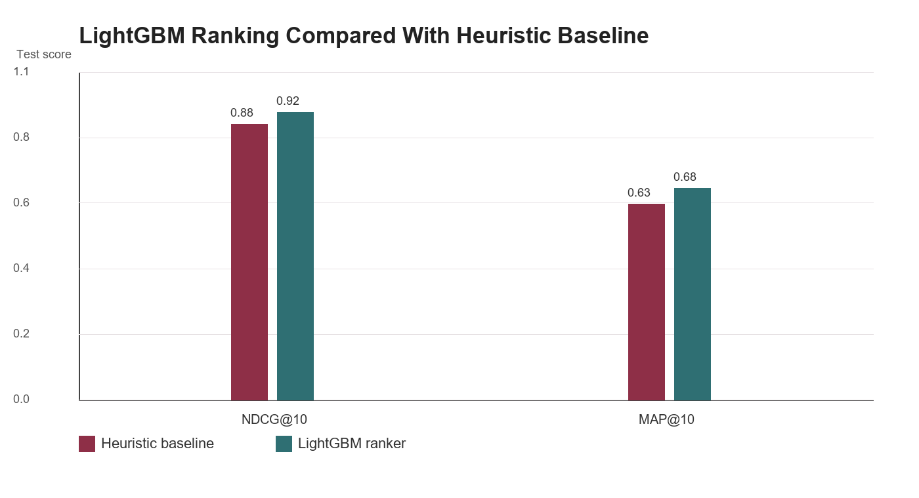

4.4.5 Stage 2 CP-SAT Optimization Results
The CP-SAT optimizer is the final decision layer. It is the correct algorithmic center of the paper because PCOSina has many non-negotiable rules. Across the four feasible thesis scenarios, the planner completed all 21 weekly meal slots without observed hard violations. In S5, the PHP 20 weekly budget was intentionally infeasible, and the system returned no-safe-plan rather than relaxing the hard budget cap.
Table 4.4.7 Stage 2 Runtime and Safe Completion Summary
Scenario | Average Runtime (s) | Planner Result | Safe Completion Outcome
S1 Base | 0.6309 | Success | 21 / 21 slots, 0 hard violations
S2 Budget and No Pork | 1.0768 | Success | 21 / 21 slots, hard budget cap met
S3 Vegetarian and Lactose Intolerant | 0.6988 | Success | 21 / 21 slots, 0 hard violations
S4 Pantry-Aware Case | 1.1201 | Success | 21 / 21 slots, 38 pantry-overlap matches
S5 Resilience/Stress Case | 3.2940 | No-safe-plan | No unsafe plan returned; infeasible hard budget preserved

4.4.6 Nutritional Quality and Constraint Outcomes
Table 4.4.8 Nutritional Quality and Constraint Outcome Comparison
Scenario | Average Calorie Deviation | Average Macro Deviation | Budget Result | Pantry Result | Hard-Constraint Outcome
S1 Base | 576.00 | 30.85% | Not budget constrained | 0 matches | 0 hard violations
S2 Budget and No Pork | 740.67 | 40.34% | PHP 1,000 cap met exactly | 0 matches | 0 hard violations
S3 Vegetarian and Lactose Intolerant | 691.00 | 35.90% | Not budget constrained | 0 matches | 0 hard violations
S4 Pantry-Aware Case | 563.00 | 30.85% | Not budget constrained | 38 pantry-overlap matches | 0 hard violations
S5 Resilience/Stress Case | Not applicable | Not applicable | PHP 20 cap infeasible | Not applicable | No-safe-plan returned

The nutrition results should be interpreted as optimization tradeoffs, not perfect clinical diet prescription. The solver balances recipe availability, Filipino meal fit, restrictions, variety, estimated cost, pantry overlap, and nutrition targets. Remaining calorie and macro deviation is therefore a realistic planning limitation, not a safety violation.

4.4.7 Pantry, Grocery, and Budget Evaluation
Table 4.4.9 Pantry, Grocery, and Budget Evaluation Summary
Area | Observed System Behavior | Defense Interpretation
Pantry-overlap behavior | S4 recorded 38 pantry-overlap matches across the completed plan. | Pantry supports ranking and grocery guidance, but the system should be described as pantry-aware rather than pantry-only.
Grocery deficit guidance | The grocery feature consolidates needed ingredients and marks pantry-covered items where item names match. | Useful for shopping guidance, but accuracy depends on user-entered pantry data and naming consistency.
Estimated price computation | Price rules and recipe costs are estimated for planning, not real-time market quotations. | Use 'estimated cost' wording in the paper and defense.
Budget hard cap | S2 met the PHP 1,000 cap; S5 returned no-safe-plan under PHP 20. | Budget is enforced when configured; infeasible budgets are not silently relaxed.

4.4.8 Compact Algorithm Comparison and Final Algorithm Choice
A short comparison is useful because it explains why the final system uses deterministic filtering plus CP-SAT instead of a purely greedy, purely ML, or generative selection approach. It should remain compact. The paper does not need a long survey of every possible recommender or optimization algorithm because PCOSina's core requirement is hard-constraint meal planning, not general recommendation.
Table 4.4.10 Algorithm Tradeoff Artifact Summary
Algorithm | Runs | Hard Violation Rate | Avg Runtime (s) | Objective Surrogate J
cpsat_two_stage | 10 | 0.0% | 2.2806 | 0.2236
greedy_heuristic | 10 | 0.0% | 0.2359 | 0.2248
gen_proxy | 100 | 100.0% | 0.0061 | 0.3076

Table 4.4.11 Why the Final Algorithm Remains Deterministic Filtering Plus CP-SAT
Alternative | Evidence-Based Finding | Final Decision
Generative/proxy selection | Very fast in the artifact, but hard-violation rate reached 100%. | Not acceptable as the final planner because it can produce unsafe or rule-breaking plans.
Greedy deterministic heuristic | Fast and useful as a baseline or fallback. In the artifact it had 0% hard-violation rate, but it lacks a global weekly optimization model and weaker infeasibility reasoning. | Useful for comparison and fallback, not the best final authority for a defense paper centered on constraints.
Pure ML ranking | Improves Stage 1 ordering, but cannot guarantee allergies, budget, repetition, or nutrition bounds by itself. | Keep as optional assistive ranking only.
Deterministic filtering + CP-SAT | Explicit hard constraints, solver diagnostics, deterministic fallback, and safe no-safe-plan behavior. | Best final fit for PCOSina and the thesis claim.

Figure 4.7 Hard-violation rate from the algorithm tradeoff artifact.
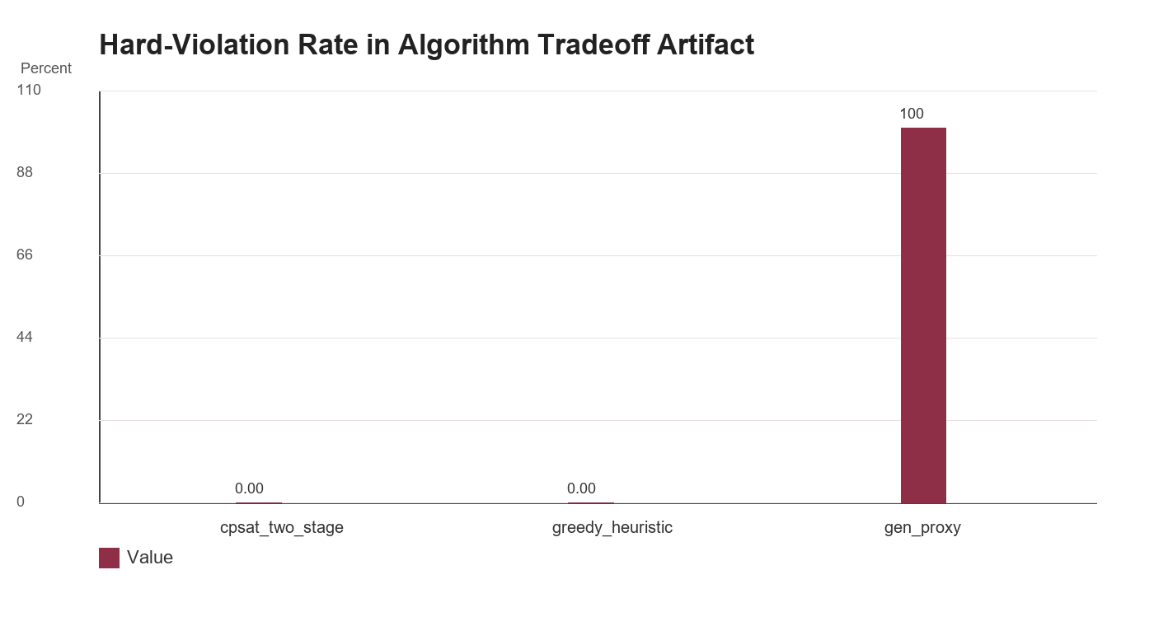
Defense wording. Do not say CP-SAT is best because it is always fastest. The stronger and truer claim is that it is the best fit because it preserves hard constraints, produces explainable optimization behavior, and fails safely when no valid plan exists.

4.4.9 Offline-First and Performance Interpretation
Table 4.4.12 Offline-First and Performance Evaluation Summary
Area | Available Evidence | Interpretation
Saved data continuity | Saved profile, meal plan, pantry, grocery, and progress information are supported by local persistence. | Users can continue viewing created information offline.
New plan generation | Optimized generation uses backend CP-SAT planning service and optional worker/queue path. | Do not claim every new optimized plan is generated fully offline.
Observed final-build runtime | Successful thesis scenarios averaged 0.6309 s to 1.1201 s; no-safe-plan stress case averaged 3.2940 s. | Local evidence supports feasibility, but runtime should be repeated on the final deployment target.
Earlier slow runs | Earlier observed runs around 207,816 ms and 188,249 ms motivated candidate-pool and backend optimization work. | Shows why the current optimized path matters.

4.4.10 Final Discussion of Algorithm Findings
The final evidence supports PCOSina's technical claim: it can build safe weekly meal plans from Filipino recipe candidates by applying deterministic safety filters, optional ranking, and CP-SAT optimization. The strongest result is not the ML metric; it is the combination of 21-slot completion for feasible scenarios and no-safe-plan behavior for an intentionally infeasible hard-budget case.
The LightGBM artifact is still useful. It shows that model-assisted ranking can improve candidate ordering over a deterministic heuristic baseline on the current model_v1 dataset. However, LightGBM should stay framed as Stage 1 assistance because it does not prove final plan safety by itself.
The algorithm comparison should be included, but only as a short defense rationale. It explains why PCOSina does not rely on a generative selector, pure ML, or a simple greedy heuristic as the final authority. The chosen design is best for this system because the application is a wellness decision-support planner with hard safety, budget, pantry, and preference constraints.
These findings validate implementation and algorithm feasibility only. They do not claim diagnosis, clinical treatment effect, PCOS symptom improvement, or respondent acceptance. Those require separate clinical, usability, expert, or respondent validation evidence.

Evidence Sources Used
Table 4.4.13 Evidence Source Index
Evidence | Path or Source | How It Was Used
Current source DOCX | docs/Algorithm Evaluation Results.docx | Existing S1-S5 benchmark and interpretation text used as the base evidence.
LightGBM model artifact | ml/offline_training/artifacts/model_v1/training_metrics.json | Current model_v1 dataset, split, AUC, NDCG@10, MAP@10, baseline, and uplift values.
Algorithm tradeoff artifact | backend/comment5_algorithm_tradeoff_summary.csv | Compact comparison across cpsat_two_stage, greedy_heuristic, and gen_proxy.
Tradeoff detail artifact | backend/comment5_algorithm_tradeoff_report.json | Run counts, formulas, solver time controls, and scenario-level records.
Benchmark runner manifest | benchmarks/runner/run_comment5_benchmark.py and benchmarks/canonical_scenarios/comment5_canonical_scenarios.json | Scenario set and artifact contract; regenerated with --use-existing-artifacts on May 17, 2026.
Validation matrix | docs/thesis_validation/05_VALIDATION_TEST_CASES.csv | Implemented and recommended system validation cases for planner, budget, no-safe-plan, grocery, and offline areas.
Retest receipt | Local pytest results from this generation run | 74 backend planner/contract tests passed; 12 ML/ranking tests passed.

